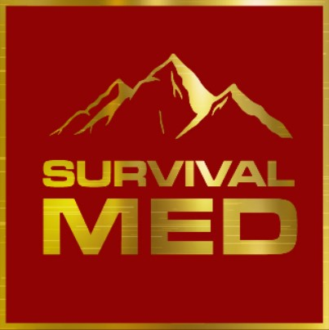
Wilderness First Responder Scenario 1
In this course, students are taught how to document their medical findings and decisions in the form of a SOAP note. This is one example of a medical case.

SUMMARY:
You’re teaching your uncle Pat to ski in January in Vermont. Although you’ve been skiing for twenty years, your uncle is very new to this. He admits he’s nervous about it, and wishes he was in better shape for it. He hasn’t been able to exercise much for the past ten years since he had a knee replacement and has gained quite a bit of weight, so he’s worried he won’t be able to keep up.
You start out on the easiest routes, keeping him away from anything too grueling or dangerous. By the afternoon, he thinks he’s starting to catch on, and he wants to try a more challenging route. You agree, and choose one with steeper terrain. However, as you start down the mountain, you realize you may have chosen one a little too difficult for him. He falls several times and has to work very hard. About half-way down the mountain, he tells you that he’s starting to feel out of breath and that his “lungs hurt.” However, wanting to prove that he can do this, he does not want to stop.
You continue down the path, turn by turn. Pat continues to get more and more out of breath and dizzy. He says his chest is starting to “squeeze,” and he wonders if he might have heartburn from the chili he ate at lunch. Curious, you ask more about the pain in his lungs. He says it’s worst near the center of his chest and “shoots toward his back.” Pat says, “it feels like someone is sitting on my chest.”
This concerns you, so you encourage him to stop and go through the assessment that you learned as a WFR.

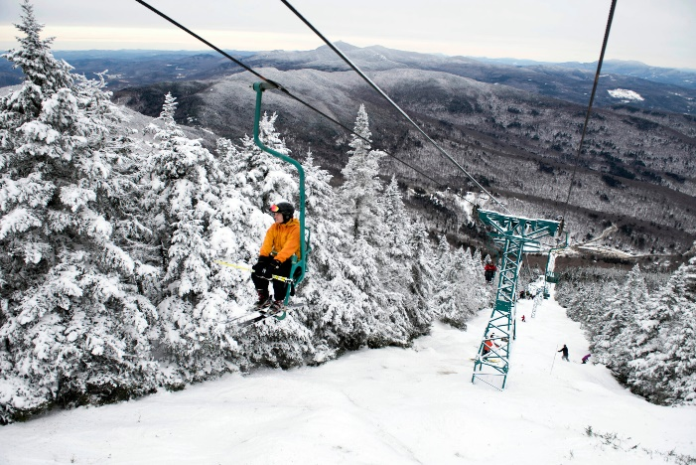
Scene Safety: Scene is safe when you move to the side of the trail, out of the way of oncoming skiers.
Primary Assessment: Pat has a fast but regular pulse and breathing, and no obvious injuries or bleeding. He is awake and alert but in moderate distress.
Secondary Assessment: Pat describes a crushing feeling in the “center of his lungs.” He also feels pain in his back. Your physical exam is very limited due to all of the winter gear Pat is wearing. However, you don’t think you hear any wheezing or abnormal breath sounds.
Time | 15:00
Level of Responsiveness (LOR) | A+O x4
Heart Rate (HR) | 100, regular
Respiratory Rate (RR) | 22, regular
Skin Color | Pink, flushed, warm
Blood Pressure (BP) | Radial pulses present
Pupils | Not taken
Temperature | Not taken

Symptoms | Patient has a crushing pain in the center of his chest that radiates to the back.
Allergies | None
Medications | Blood pressure medication  Pain medication for occasional knee pain  Pepto Bismol for occasional heartburn
Pertinent History | 66 years old. Some cardiac risk factors (obesity, smoking). Frequent heartburn after meals.
Last In/Out | Patient ate and drank a full meal at lunch two hours ago.
Events | Patient was navigating a difficult ski route when the pain and shortness of breath started.

(S) Subjective:

(O) Objective:

(A) Assessment:

(P) Plan:

Follow-up questions:
1. Should Pat be evacuated? If so, how urgently? What are you the most concerned about?

2. Is it ok for Pat to ski the rest of the way down the hill?

3. Back at the ski lounge, someone finds a medical kit in the back office. What kind of medication(s)- if any- would you give Pat?

